Introduction

The Festival welcomes everyone, and is developing its access offer to the public.

We are currently working with Attitude is Everything towards Charter Status, to improve access for D/deaf and Disabled artists, volunteers, participants and staff.

Read more about Attitude is Everything: www.attitudeiseverything.org.uk

An Access and Inclusion Advisory Group has been created to advise the Festival. This Group is made up of people with a range of impairments who are championing a stronger, more inclusive approach, testing new ideas and finding creative solutions.

Festival Staff have taken part in Disability, Equality and Customer Care Training, aiming to improve access for all Disabled people including Wheelchair Users, Deaf or Hard of Hearing, Blind and Visually Impaired people, those with long-term health conditions and Neurodiverse customers.

Our friendly team of volunteers wear bright pink T-shirts, and are available with information about events and will help to make your experience enjoyable.

If you have any suggestions for improving access at the Festival, please contact: Ursula White (Community Inclusion) by email: Ursula.White@stables.org.uk

If you would like to receive information by email about access at the Festival email, please contact: access@thestables.org
Covid-19 Safety
The safety of Festival audiences, artists, volunteers and staff is our highest priority.

As well as following all government and industry guidelines, we’re working closely with specialist safety advisors to ensure all our event locations are Covid-safe and secure for everyone.

We are pleased to reassure audiences that all Festival events have been organised in line with the government’s Covid-19 Step 3 guidelines, and events can be attended as planned.

We will update our website with more information between now and the Festival.

Festival Stewards will be at all Festival sites to assist.

More information is here: https://ifmiltonkeynes.org/covid-19-safety

About the Festival

Extended to 21 days, this year’s Festival gives people more time and space to enjoy events across the city and online.

With most of the programme free to attend, there’s a focus on family events, performances and art installations, pop-ups and a series of ‘virtually live’ online concerts.

For more information, please go to the Festival’s website:

www.ifmiltonkeynes.org
https://ifmiltonkeynes.org/

Festival Social media:
Twitter and Facebook: @IFMKfest
Instagram: ifmkfest
Hashtag: #IFMKfest

Booking Tickets

Online: www.ifmiltonkeynes.org
Our Box Office Staff will be happy to help with any enquiries regarding your ticketing and access requirements.

Box Office: 01908 280800

Middleton Hall, centre:mk Box Office: In-person on Fridays, Saturdays, Sundays, from 10am to 5.45pm

Email the Box Office: access@stables.org

Booking for wheelchair, companion and personal assistant seats
Please contact the Box Office by email access@thestables.org or call 01908 280800.

Festival Information
This year we are producing a fold-out Festival Guide instead of our usual full brochure. Please refer to our website for the latest information on events.

Accessible Shows
Some shows have BSL interpretation or Audio Description.

Access information for each show is on event pages. This link will take you to What’s On: https://ifmiltonkeynes.org/whats-on

Access Information, including a BSL Guide to the Festival by Sam Dore:
https://ifmiltonkeynes.org/access

IF: Online
The Festival has a programme of events, talks and concerts presented online.

There will be additional access options available, including Captioned content, BSL and Audio Description.

Find out more: https://ifmiltonkeynes.org/if-online

Access At The Festival
All shows and sites are relaxed, and we invite audiences to feel at home in our company.

For some events, access content will be available online via your mobile phone. Please bring a charging pack for your phone if you are concerned about battery.

Festival Staff, Stewards and Volunteers
Available to assist and guide you at all Festival locations.

Signage at Events
Each event and Festival location will have signage to provide information and guide you to Viewing Areas, Parking, Toilets and other available facilities.

Assistance and Service Dogs are Welcome
Information on our webpages about each event will advise what kind of event it is and inform you of any special effects that might affect your dog's comfort.

You can also contact the Festival team: access@stables.org

The pages that follow include a photo and description, and also a weblink for each Festival event.

Events take place from 10 to 30 July.

21 incredible days…

Time to enjoy

Space to discover

Festival Events: 2021
For updates and additions to the programme, please check the Festival website and social media.

Gaia by Luke Jerram
Saturday 10 - Friday 30 July
10.30am - 5.30pm: Please check website as time may vary
Middleton Hall, centre:mk MK9 3EP
FREE – no need to book a ticket
Gaia is a stunning replica of our planet. Created by UK artist Luke Jerram, Gaia measures seven metres in diameter and features 120dpi detailed NASA imagery of the Earth’s surface.
Artist: http://my-earth.org/
Website: https://ifmiltonkeynes.org/event/gaia-by-luke-jerram

Tours available:
- Audio Described Tour on Saturday 24 July
BSL Tour Available on Saturday 24 July
- Relaxed Performance and Relaxed Tour on Tuesday 20 July
Information and to book: https://ifmiltonkeynes.org/whats-on

Assistance Dogs Welcome Disabled Parking available for Blue Badge Holders
Drop-Off and Pick-Up Point available at Entrance 14 to centre:mk
Assistive Listening and Hearing Loop available
Online Event and Digital Access available
Phone: Content Available via Phone
Seating Available
Disabled Toilets and Changing Spaces Toilet available
Wheelchair Accessible
Family Friendly
Move Around to Experience the Event
Additional Information
There will be an audio recording used at this location/audio descriptive of sound recording available, three musical performances and one talk will be held at this location.
Infrared Hearing Loop available
centre:mk facilities include Disabled Toilets and a Changing Spaces Toilet which is a short distance from Middleton Hall.
The main information point for the Festival will be at this location on Fridays, Saturdays and Sundays
Induction Loop is available for Hard of Hearing customers
No ticket or booking is required

The Earth Music Series of concerts are set under Gaia in Middleton Hall:

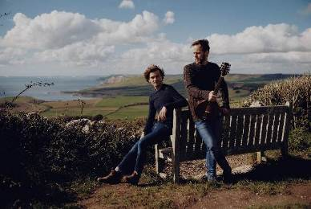

Earth Music Series: Ninebarrow
Friday 16 July, 7.30pm
Under Gaia, Middleton Hall, centre:mk, MK9 3EP
Tickets £12.50, Seated concert, unreserved
Running time: 60 minutes
Ninebarrow are a multi-award-winning folk duo, who are impressing audiences across the country with their breath-taking vocal harmonies and melodies, and an innovative and captivating take on the folk tradition.
Artist: https://www.ninebarrow.co.uk/
Website: https://ifmiltonkeynes.org/event/earth-music-series-ninebarrow

Assistance Dogs Welcome
Disabled Parking available for Blue Badge Holders
Drop-Off and Pick-Up Point available at Entrance 14 to centre:mk
Assistive Listening and Hearing Loop Available
Seated Event
Disabled Toilets and Changing Spaces Toilet available
Viewing Area
Wheelchair Accessible
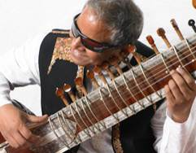

Earth Music Series: Baluji Shrivastav OBE
Wednesday 21 July, 7.30pm
Under Gaia, Middleton Hall, centre:mk, MK9 3EP
Tickets £12.50
Seated concert, unreserved
Running time: 60 minutes

Virtuoso multi-instrumentalist Baluji Shrivastav OBE plays Moon-inspired ragas on sitar, accompanied by Nafees Irfan on tablas. The concert opens with a song by Linda Shanovitch.

Artist: http://www.baluji.com
Website: https://ifmiltonkeynes.org/event/baluji-shrivastav

Assistance Dogs Welcome
Disabled Parking available for Blue Badge Holders
Drop-Off and Pick-Up Point available at Entrance 14 to centre:mk
Assistive Listening and Hearing Loop Available
Seated Event
Disabled Toilets and Changing Spaces Toilet available
Viewing Area
Wheelchair Accessible

Additional Information
Baluji Shrivastav, OBE is Registered Blind

Earth Music Series: Maya Youssef
Thursday 29 July at 7.30pm
Gaia, Middleton Hall, centre:mk, MK9 3EP
Tickets £12.50
Seated concert, unreserved
Running time: 60 minutes

Syrian musician Maya Youssef is hailed as ‘queen of the qanun’ - the 78-stringed Middle Eastern plucked zither. For her, the act of playing music is a life-affirming act - an antidote to what is happening across the world.
Artist: https://mayayoussef.com/
Website: https://ifmiltonkeynes.org/event/maya-youssef

Assistance Dogs Welcome
Disabled Parking available for Blue Badge Holders
Drop-Off and Pick-Up Point - Entrance 14 at centre:mk
Assistive Listening and Hearing Loop Available
Seated Event
Disabled Toilets and Changing Spaces Toilet available
Viewing Area
Wheelchair Accessible
Family Friendly

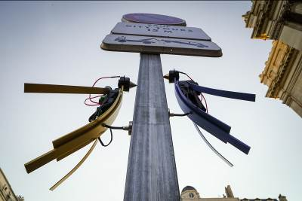

Marco Barotti: The Woodpeckers
Saturday 10 - Friday 30 July
FREE Pop-Ups across Milton Keynes City Centre
Charming robotic woodpeckers pop-up across the City Centre, transforming invisible signals from wireless technology and mobile communication, into acoustic rhythmic beats, tapped out on the City’s urban architecture.

Artist: https://www.marcobarotti.com/
Website: https://ifmiltonkeynes.org/event/marco-barotti-the-woodpeckers

Tours available:
- Audio Described Tour on Saturday 24 July
BSL Tour Available on Saturday 24 July
- Relaxed Performance and Relaxed Tour on Tuesday 20 July
Information and to book: https://ifmiltonkeynes.org/whats-on

Assistance Dogs Welcome
Disabled Parking available for Blue Badge Holders
Drop-Off and Pick-Up Point available
Easy Read
Phone: The Woodpeckers respond to Mobile Phone signals
Disabled Toilets and Changing Spaces Toilet available
Wheelchair Accessible
Family Friendly
Join In and Take Part
Move Around to Experience Event
Outdoor Event
Speech Free

Additional notes
The Woodpeckers pop-up in different locations each day in Central Milton Keynes. Contact access@stables.org to find out where the Woodpeckers are on the day of your visit or stay in touch via Social Media #IFMKfest
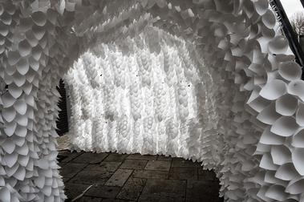

World Premiere
Anna Berry: Breathing Room
Saturday 10 - Friday 30 July
Queen’s Court in centre:mk MK9 3ES
10.30am - 5.30pm
Relaxed sessions available Sunday 11 to Thursday 29 July
FREE: Book for Relaxed Sessions only

Breathing Room is a new kinetic installation that people can walk and move within. Creating an otherworldly experience, paper-like cones line the structure that is powered by mechanics to move as if it is breathing.
Artist: http://www.annaberry.co.uk/
Website: https://ifmiltonkeynes.org/event/anna-berry-breathing-room

Tours available:
- Audio Described Tour on Saturday 24 July
BSL Tour Available on Saturday 24 July
- Relaxed Performance and Relaxed Tour on Tuesday 20 July
Information and to book: https://ifmiltonkeynes.org/whats-on

Assistance Dogs Welcome
Disabled Parking available for Blue Badge Holders
Drop-Off and Pick-Up Point available near to Marks & Spencer and Costa Coffee
Easy Read
Seated Event/Seating available
Disabled Toilets and Changing Spaces Toilet available
Wheelchair Accessible

What to expect
Family Friendly
Move Around to Experience Event
Outdoor Event
Speech Free

Additional Information - Relaxed Visiting Times:

Sunday 11 July: 10.30am – 11.30am
Tuesday 13 July: 10.30 – 11.30am
Thursday 15 July: 2.30 – 3.30pm
Sunday 18 July: 10.30am – 11.30am
Tuesday 20 July: 10.30 – 11.30am
Thursday 22 July: 2.30 – 3.30pm
Sunday 25 July: 10.30am – 11.30am
Tuesday 27 July: 10.30am – 11.30am
Thursday 29 July: 2.30pm – 3.30pm

To book please contact access@stables.org

These relaxed visiting times are designed for people with autism spectrum conditions and their families so they can enjoy the arts together in a stress-free environment.

They are also suitable for people with sensory conditions or learning difficulties.

Breathing Room has been designed to be accessible and has a relaxed attitude to noise and movement, with gentle light and sound effects.

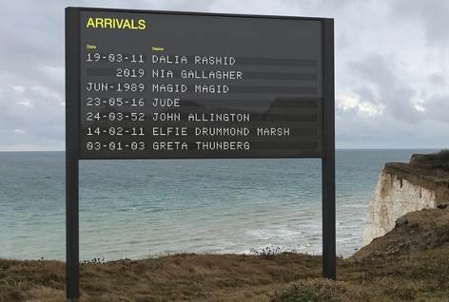

Yara + Davina: Arrivals + Departures
Saturday 10 - Friday 30 July
10.30am - 5pm
City Square MK9 4AD
FREE: No need to book
A public artwork about birth, death and the journey in between. The artwork displays names of people, submitted by the public in-person or online, as a way of commemorating a birth (an arrival) or a death (a departure).

Submit names to go on the boards in three ways:
Online via: https://www.arrivalsanddepartures.net/
In person at the artwork – a Festival steward will be on hand to assist
At Milton Keynes Central Library

Artists: https://www.yaraanddavina.com/
Website: https://ifmiltonkeynes.org/event/yara-davina-arrivals-departures

Tours available:
- Audio Described Tour on Saturday 24 July
BSL Tour Available on Saturday 24 July
- Relaxed Performance and Relaxed Tour on Tuesday 20 July
Information and to book: https://ifmiltonkeynes.org/whats-on

Assistance Dogs Welcome
Disabled Parking available for Blue Badge Holders
Drop-Off and Pick-Up Point available near to Marks & Spencer and Costa Coffee
Easy Read
Phone: Content Available via Phone
Seating available
Disabled Toilets and Changing Spaces Toilet available
Audio Described Tour and Visual Description
Wheelchair Accessible

What to expect
Family Friendly activity
Join In and Take Part
Outdoor Event
Speech Free

Many of the events that follow are in Campbell Park.

Here is a basic map showing key locations - mostly at the City end of the Park:

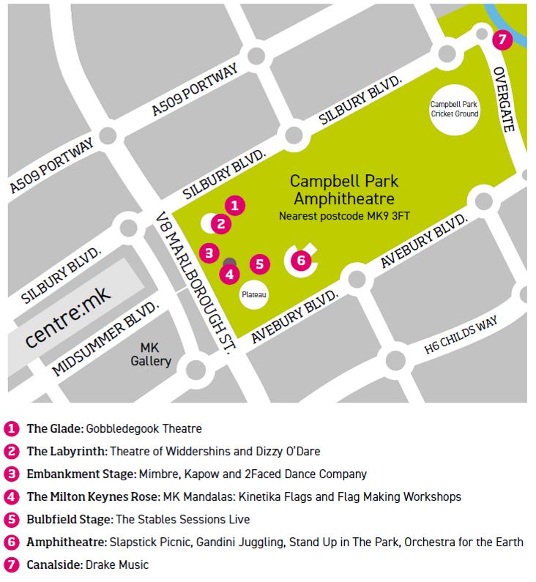
Accessing Campbell Park

From the City:
Recommended drop off and pick up point is at MK Gallery and MK Theatre, from there, there is a walk-way bridge to The Milton Keynes Rose in the Park.

Many of the Family Focus events are clustered near to the Rose. There are trackways and paths in this area.

Festival stewards and volunteers in Pink T-shirts will be available to provide any assistance. There will also be signage direction people to the various locations in the Park for performances.

For Campbell Park Amphitheatre:
Drop off and Pick up point is at Campbell Park, opposite the Budgens shop on Avebury Boulevard.

Wheelchair access to the Amphitheatre is by Campbell Heights Housing Development.

From the Plateau, there are paths to lead you to the Amphitheatre.
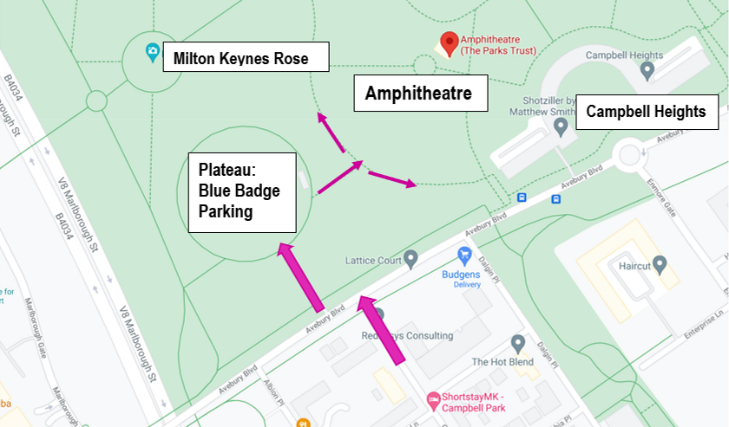

See this on Google maps here: https://goo.gl/maps/TnkXW1ukFieGUXJh6

Drake Music: Planted Symphony
Wednesday 14 - Sunday 18 July, 11am - 5pm
Campbell Park: Canalside
FREE: No need to book

Music and nature combine in this audio trail, using a sonic app to guide you to intriguing installations. Includes BSL, audio description, resting points and Subpacs available for D/deaf and hard of hearing audience members.

Suitable for adults and families with older children.

Note: Subpacs translate sound into vibration and over-ear headphones, which are compatible with hearing aids. - please book a Subpac in advance by calling the Box Office 01908 280800 or emailing access@stables.org

The Planted Symphony App is available by this webpage:
https://plantedsymphony.com/

In the App Stores, the App has this icon:

Company: https://www.drakemusic.org/
Website: https://ifmiltonkeynes.org/event/drake-music

Easy Read is available for download on the Festival’s website
Assistance Dogs Welcome
Audio Described Tour and Visual Description
Some BSL included within the experience
Disabled Parking available for Blue Badge Holders
Drop-Off and Pick-Up Point available
Headphones Used in Event
Phone: Content Available via Phone
Relaxed Performance and Relaxed Tour
Seating Available
Disabled Toilets available on Campbell Park Plateau
Wheelchair Accessible

What to Expect
Family Friendly
Join In and Take Part
Make Some Noise
Move Around to Experience Event
Outdoor Event
Additional information
This outdoor trail is less than 400m long and lasts about 20 to 30 minutes
There are places to rest along the route
Please bring your own mobile phone if you have one
You can also borrow, mobile phones, headphones and Subpacs, a wearable jacket which allows you to experience the vibrations form the music.

Please note there is no information point, or toilet at this location

Please use Festival toilets including Disabled Toilet on the Campbell Park Plateau.

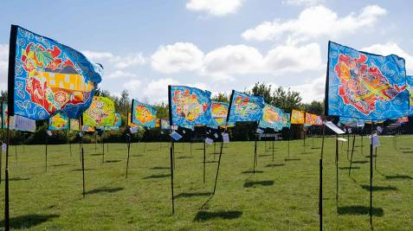

MK Mandalas: Kinetika Flags
Friday 16 - Sunday 18 July and Friday 23 - Sunday 25 July
The Milton Keynes Rose, Campbell Park
FREE

Internationally renowned UK company Kinetika is working with over 150 people from community groups in Milton Keynes to create a set of 30 large-scale, hand-painted silk flags for display at The Milton Keynes Rose.

Mandalas are geometrically laid out circles arranged into sections organised around a single, central point.

Participating Groups from MK: The Frank Moran Centre, Camphill Communities, Broughton & Brooklands Community Connectors, Friends & Families MK, GrandMentors from Volunteering Matters, MK ACT, the Milton Keynes Hindu Association, Sew and Grow, the YMCA MK and MK Collective.

Further Information - About MK Mandalas & Resource Pack:
https://kinetika.co.uk/portfolio/mk-mandalas

Website: https://ifmiltonkeynes.org/event/mk-mandalas-kinetika-flags

Accessing Campbell Park:
Recommended drop off and pick up point is at MK Gallery and MK Theatre, from there, there is a walk-way bridge to The Milton Keynes Rose in the Park.

Many of the Family Focus events are clustered near to the Rose. There are trackways and paths in this area.

Festival stewards and volunteers in Pink T-shirts will be available to provide any assistance. There will also be signage direction people to the various locations in the Park for performances.
Assistance Dogs Welcome
Disabled Parking available for Blue Badge Holders
Drop Off Pick Up Point Available
Seating Available
Disabled Toilets available
Wheelchair Accessible
What to Expect
Family Friendly
Outdoor Event
Speech Free

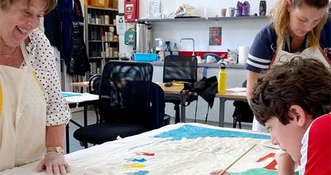

FAMILY FOCUS WEEKEND
Flag Making Workshops
Saturday 17 and Sunday 18 July, 11am - 4pm
Workshops run every 30 minutes - the last session is at 3.30pm each day
Campbell Park: By The Milton Keynes Rose
FREE: Book a Place
Make a flag and take it home! Workshops for children and adults inspired by the Festival’s MK Mandalas flag project, run by artists Rachel Wright and Cathy Ebbels. Materials will be provided, though please book a place and wear an apron or overall.

Website: https://ifmiltonkeynes.org/event/flag-making-workshop

This event is inspired by the MK Mandalas: Kinetika Flags project: Website: https://ifmiltonkeynes.org/event/mk-mandalas-kinetika-flags

Access Symbols
Assistance Dogs Welcome
BSL
Disabled Parking
Drop off & Pick Up Point
Seating Available
Disabled Toilets available
Wheelchair Accessible

What to Expect
Family Friendly
Join In and Take Part
Outdoor Event

A volunteer BSL interpreter will be available between 2- 4pm on Saturday 17 and Sunday 18 July.

Accessing Campbell Park:
Recommended drop off and pick up point is at MK Gallery and MK Theatre, from there, there is a walk-way bridge to The Milton Keynes Rose in the Park.

Many of the Family Focus events are clustered near to the Rose. There are trackways and paths in this area.

Festival stewards and volunteers in Pink T-shirts will be available to provide any assistance. There will also be signage direction people to the various locations in the Park for performances.

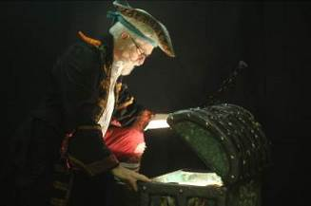

FAMILY FOCUS WEEKEND
Theatre of Widdershins: Treasure Chest Tales
Saturday 17 and Sunday 18 July, from 11.15am
Campbell Park: Labyrinth
FREE: Book a ticket
Incorporating music, puppets and audience interaction, Widdershins skilfully brings a series of magical and enchanting stories to life to entertain all ages. Each Tale lasts approximately 40 minutes

Saturday 17 July
11.15am: The Princess & The Pea
1.15pm: The Hare & The Hedgehog
3.15pm: The Many Legged Musicians of Bremen: This show is BSL interpreted

Sunday 18 July
11.15am : Granny Dumpling
1.15pm: Nanooshka, Queen of the Goats
4pm: Ug, Bug & Dug

Company: https://www.widdershins.co.uk/
Website: https://ifmiltonkeynes.org/event/theatre-of-widdershins-treasure-chest-tales

BSL Interpreted show: The Many Legged Musicians of Bremen on Sunday 18 July at 3.15pm

Accessing Campbell Park:
Recommended drop off and pick up point is at MK Gallery and MK Theatre, from there, there is a walk-way bridge to The Milton Keynes Rose in the Park.

Many of the Family Focus events are clustered near to the Rose. There are trackways and paths in this area.

Festival stewards and volunteers in Pink T-shirts will be available to provide any assistance. There will also be signage direction people to the various locations in the Park for performances.

Assistance Dogs Welcome
Disabled Parking
BSL
Assistive Listening and Hearing Loop available
Seating Available
Disabled Toilets available
Viewing Area
Wheelchair Accessible

What to Expect
Family Friendly
Outdoor Event
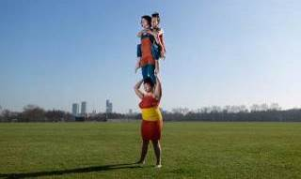

FAMILY FOCUS WEEKEND
Mimbre: Lifted
Campbell Park: The Embankment Stage
Saturday 17 and Sunday 18 July, 11.15am and 2.30pm
FREE: Book a ticket
Lifted mixes dance, theatre and circus to celebrate the expressions and impressions that appear when Mimbre’s all-female cast of three strong women move, lift and balance each other. The show runs for 35 minutes.

Company: https://mimbre.co.uk/
Website: https://ifmiltonkeynes.org/event/mimbre-lifted

Accessing Campbell Park:
Recommended drop off and pick up point is at MK Gallery and MK Theatre, from there, there is a walk-way bridge to The Milton Keynes Rose in the Park.

Many of the Family Focus events are clustered near to the Rose. There are trackways and paths in this area.

Festival stewards and volunteers in Pink T-shirts will be available to provide any assistance. There will also be signage direction people to the various locations in the Park for performances.

Assistance Dogs Welcome
Disabled Parking available for Blue Badge Holders
Assistive Listening and Hearing Loop available
Disabled Toilets Available
Seating Available
Viewing Area
Wheelchair Accessible

What to Expect
Family Friendly
Outdoor Event
Speech Free

Additional information
Trackway may be applied to grass surface dependent on weather.

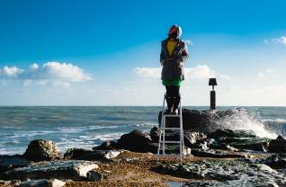

FAMILY FOCUS WEEKEND
Gobbledegook Theatre: Cloudscapes
Saturday 17 & Sunday 18 July
11.30am, 12.30pm, 1.30pm, 2.30pm, 3.30pm 4.30pm - Run time approx 40 mins
Campbell Park: The Glade. FREE: Book a ticket
Cloudscapes is a wonderfully calming and restful outdoor experience that combines calm clouds, mindful moments, contentment and words, set in an outdoor cloud-gazing area.

Company: https://www.gobbledegooktheatre.com/
Cloudscapes at home soundtrack: https://www.gobbledegooktheatre.com/cloudscapes-at-home-digital

Website: https://ifmiltonkeynes.org/event/gobbledegook-theatre-cloudscapes

Accessing Campbell Park:
Recommended drop off and pick up point is at MK Gallery and MK Theatre, from there, there is a walk-way bridge to The Milton Keynes Rose in the Park.

Many of the Family Focus events are clustered near to the Rose. There are trackways and paths in this area.

Festival stewards and volunteers in Pink T-shirts will be available to provide any assistance. There will also be signage direction people to the various locations in the Park for performances.
Assistance Dogs Welcome
Disabled Parking available for Blue Badge Holders
Assistive Listening and Hearing Loop available
Relaxed Performance and Relaxed Tour
Seating Available
Wheelchair Accessible
Family Friendly
Join In and Take Part
Outdoor Event
Additional information
Bean Bags are provided for cloud gazing.
Cloud gazing can also take place from a seated position or wheelchair.
Tour of the set and Cloud Museum is available on request for Visually Impaired audience members, to take place half an hour before the event opens.
Although Cloudscapes is about gazing at the sky, the text is very descriptive of cloud forms and types, so there is not a need for additional audio description.
Large print copies of the full text are available

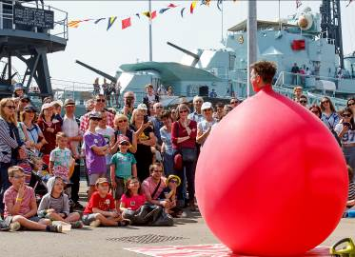

FAMILY FOCUS WEEKEND
Dizzy O’Dare: The Giant Red Balloon Show
Saturday 17 and Sunday 19 July, 12.15pm and 2.15pm
Campbell Park: Labyrinth
Each performance lasts approximately 45 minutes
FREE: Book a ticket
This hilarious family show features feverous balloon sculptures, high-energy comedic performance and a homage to the iconic red balloon which featured in the 1984 TV advert to promote Milton Keynes as a great place to live!

Company: http://www.dizzyodare.com/Home.html
Website:
https://ifmiltonkeynes.org/event/dizzy-odare-the-giant-red-balloon-show

BSL Interpreted show: Sunday 18 July at 12.15pm
Accessing Campbell Park:
Recommended drop off and pick up point is at MK Gallery and MK Theatre, from there, there is a walk-way bridge to The Milton Keynes Rose in the Park.

Many of the Family Focus events are clustered near to the Rose. There are trackways and paths in this area.

Festival stewards and volunteers in Pink T-shirts will be available to provide any assistance. There will also be signage direction people to the various locations in the Park for performances.

Assistance Dogs Welcome
Disabled Parking available for Blue Badge Holders
Assistive Listening and Hearing Loop available
Disabled Toilets available on Campbell Park Plateau
Viewing Area
Wheelchair Accessible
What to Expect
Family Friendly
Make Some Noise
Outdoor Event

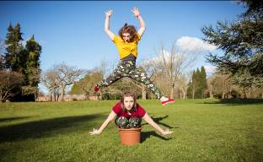

FAMILY FOCUS WEEKEND
Kapow: Grow
Campbell Park: The Embankment Stage
Saturday 17 and Sunday 18 July
12.20pm and 3.35pm
Each performance lasts approximately 25 minutes
FREE: Book a ticket
A lively, energetic and vibrant dance-theatre performance that is a playful, comedic and touching celebration of nature’s power to rejuvenate itself, take over spaces and grow through the cracks.

Company: https://www.kapowdance.co.uk/
Website: https://ifmiltonkeynes.org/event/kapow-grow

Accessing Campbell Park:
Recommended drop off and pick up point is at MK Gallery and MK Theatre, from there, there is a walk-way bridge to The Milton Keynes Rose in the Park.

Many of the Family Focus events are clustered near to the Rose. There are trackways and paths in this area.

Festival stewards and volunteers in Pink T-shirts will be available to provide any assistance. There will also be signage direction people to the various locations in the Park for performances.

Assistance Dogs Welcome
Disabled Parking available for Blue Badge Holders
Assistive Listening and Hearing Loop available
Disabled Toilets available on Campbell Park Plateau
Seating Available
Viewing Area
Wheelchair accessible
What to Expect
Family Friendly
Outdoor Event
Speech Free

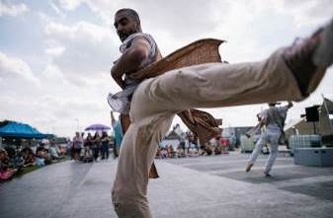

FAMILY FOCUS WEEKEND
2Faced Dance Company: Power
Saturday 17 and Sunday 18 July
1.30pm and 4.30pm
Campbell Park: The Embankment Stage
FREE: Book a ticket

Striking, physically impressive and performed by three explosive dancers, 2Faced Dance’s fearless new show Power explores our relationship with authority and control. Who leads? Who follows? Who holds the power?

Company: https://www.2faceddance.co.uk/
Website: https://ifmiltonkeynes.org/event/2faced-dance-power

Accessing Campbell Park:
Recommended drop off and pick up point is at MK Gallery and MK Theatre, from there, there is a walk-way bridge to The Milton Keynes Rose in the Park.

Many of the Family Focus events are clustered near to the Rose. There are trackways and paths in this area.

Festival stewards and volunteers in Pink T-shirts will be available to provide any assistance. There will also be signage direction people to the various locations in the Park for performances.

Assistance Dogs Welcome
Disabled Parking available for Blue Badge Holders
Assistive Listening and Hearing Loop available
Disabled Toilets available on Campbell Park Plateau
Seating Available
Viewing Area
Wheelchair Accessible
What to Expect
Family Friendly
Outdoor Event
Speech Free

The Stables Sessions: Live On The Bulbfield Stage
Saturday 17 and Sunday 18 July
From 12noon each day
Each Session lasts approximately 45 minutes
Campbell Park: The Bulbfield
FREE: Book a ticket

A weekend of open-air live music performances in Campbell Park that place a spotlight on new sounds, emerging talent and unsigned artists.

Website: https://ifmiltonkeynes.org/event/the-stables-sessions-live

Saturday 17 July

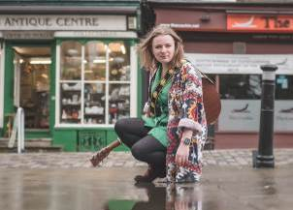
12noon: Lizzy Hardingham
https://www.lizzyhardingham.com/

1.15pm: Anna Hester
https://annahester.com/
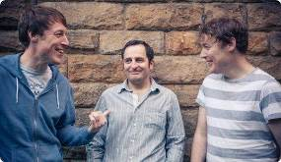
2.30pm: Candi's Dog
https://candisdog.com/

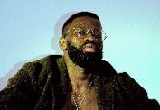
3.45pm: Manny & The Coloured Sky
https://www.facebook.com/Thecolouredsky/

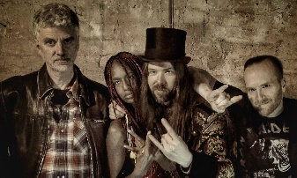
5pm: 4th Labyrinth
https://4lab.co.uk/

Sunday 18 July

12noon: Hannah Scott
http://www.hannahscott.co.uk/

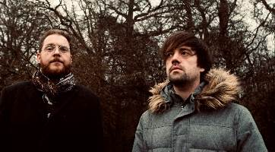
1.15pm: Smith and Brewer
https://smithandbrewer.com/
2.30pm: Joe Miles
http://www.joemilesofficial.com/

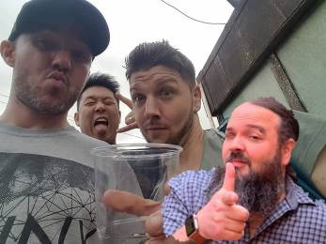
3.45pm: Inlak’esh
https://www.inlakesh.co.uk/

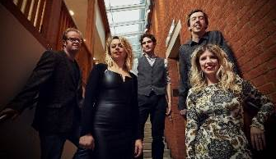
5pm: Fred's House
http://fredshousemusic.co.uk/

A volunteer BSL interpreter will be available at The Stables Sessions between 2pm and 4pm on both Saturday 17 and Sunday 18 July

Accessing Campbell Park:
Recommended drop off and pick up point is at MK Gallery and MK Theatre, from there, there is a walk-way bridge to The Milton Keynes Rose in the Park.

Many of the Family Focus events are clustered near to the Rose. There are trackways and paths in this area.

Festival stewards and volunteers in Pink T-shirts will be available to provide any assistance. There will also be signage direction people to the various locations in the Park for performances.

Assistance Dogs Welcome
Disabled Parking available for Blue Badge Holders
Seating Available
Disabled Toilets available
Wheelchair Accessible

What to Expect
Family Friendly
Join In and Take Part
Outdoor Event

The Stables Sessions information ends here

Slapstick Picnic: The Importance of Being Earnest
Saturday 17 July, 1.30pm and 5pm
Campbell Park: Amphitheatre (nearest postcode MK9 3FT)
Tickets £10
Running time: 1 hour 40 mins (no interval)
Age guide: 8+
Marvellous feats of performance and culinary capers await in this adaptation of Oscar Wilde’s classic comedic play, from the creators of The HandleBards who brought Romeo and Juliet to the Festival in 2018.

Website:
https://ifmiltonkeynes.org/event/slapstick-picnic-the-importance-of-being-earnest

For Campbell Park Amphitheatre:
Drop off and Pick up point is at Campbell Park, opposite the Budgens shop on Avebury Boulevard.

Wheelchair access to the Amphitheatre is by Campbell Heights Housing Development. From the Plateau, there are paths to lead you to the Amphitheatre.

Assistance Dogs Welcome
BSL Interpreted
Disabled Parking available for Blue Badge Holders
Drop-Off and Pick-Up Point available
Assistive Listening and Hearing Loop available
Seating available
Wheelchair Accessible

What to Expect
Family Friendly
Make Some Noise
Outdoor Event
Special Effects
Additional information
There is a Pedestrian trackway leading to a designated viewing area
Accessible route into the Amphitheatre – A volunteer steward will direct you
Accessible Toilets available on the Events Plateau.

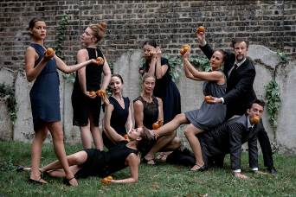

Gandini Juggling: Smashed2
Sunday 18 July, 2.15pm and 4pm
Campbell Park: Amphitheatre (nearest postcode MK9 3FT)
Tickets: Adults £5 Under 16s £3, Family x 4 (max 2 adults) £12
Performances last approximately 35 minutes
Age guidance: Families/children ages 8+
80 oranges, 7 watermelons and 9 performers all feature in this funny and inventive show that combines juggling, dance-theatre and comedy performed with masterful stagecraft, meticulous unison and split-second timing.

Company: http://www.gandinijuggling.com/
Website: https://ifmiltonkeynes.org/event/gandini-juggling-smashed2

For Campbell Park Amphitheatre:
Drop off and Pick up point is at Campbell Park, opposite the Budgens shop on Avebury Boulevard.

Wheelchair access to the Amphitheatre is by Campbell Heights Housing Development.

From the Plateau, there are paths to lead you to the Amphitheatre.

Assistance Dogs Welcome
Disabled Parking available for Blue Badge Holders
Drop-Off and Pick-Up Point available
Assistive Listening and Hearing Loop available
Seating available
Wheelchair Accessible
What to Expect
Family Friendly
Make Some Noise
Outdoor Event
Additional information
There is a Pedestrian trackway leading to a designated viewing area
There is an Accessible route into the Amphitheatre - A steward will guide you
Accessible event toilets available on events plateau

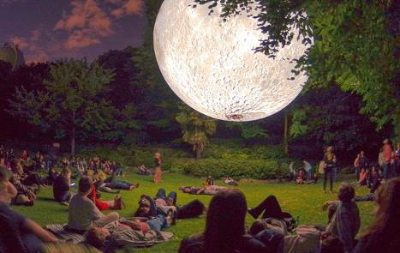

Museum of the Moon by Luke Jerram
Thursday 22 - Sunday 25 July

Thursday 22 July, 10am - 9pm
Friday 23 July, 10am - 11pm
Saturday 24 July, Afternoon and Evening only 4.30pm - 11pm
Sunday 25 July, 10am - 9pm

The Tree Cathedral, Newlands MK15 0DT
FREE: Please book a ticket for a 30-minute time-slot to attend this event

Luke Jerram’s Museum of the Moon will be set outdoors within Milton Keynes’ spectacular Tree Cathedral. Measuring seven metres in diameter, the Moon features 120dpi detailed NASA imagery of the lunar surface.

Artist: https://my-moon.org/
Website: https://ifmiltonkeynes.org/event/museum-of-the-moon-by-luke-jerram

A volunteer BSL available on Friday 23 July - Please email access@stables.org to book

Assistance Dogs Welcome
Disabled Parking available for Blue Badge Holders
Drop-Off and Pick-Up Point available at The Tree Cathedral Car Park
Seating Available
Disabled Toilets
Wheelchair Accessible
Family Friendly
Move Around to Experience Event
Outdoor Event
Speech Free

Additional Information
There will be a dedicated Disabled car park on the grassed area just off the main Tree Cathedral car park.

There are Disabled Event Toilets in this location

Access to the Tree Cathedral is via a good quality pathway.

Ground lighting will act as a guide for visually impaired people within the Tree Cathedral

Please note that some of the central pathway inside and through the Tree Cathedral is uneven in places - please take care.

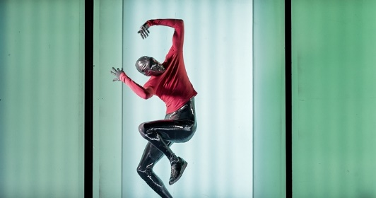

Requardt & Rosenberg: Future Cargo
Friday 23 and Saturday 24 July
5pm and 9pm
Show duration: 50 minutes
The Point Car Park (next to The Point, MK9 3NB)
Unreserved Seating
Tickets £5, Under 16s £3, Family Ticket (4 people, max 2 adults) £12
A truck arrives, loaded with a mystery shipment. As the sides roll up a large-scale immersive dance spectacle begins and, with a soundtrack heard through headphones, we glimpse into an other-worldly parallel universe…

Company: https://www.requardt-rosenberg.com/
Website: https://ifmiltonkeynes.org/event/requardt-rosenberg-future-cargo

Assistance Dogs Welcome
Disabled Parking available for Blue Badge Holders
Drop-Off and Pick-Up Point available
Headphones Used in Event
Easy Read is available on the event webpage
Seating Available
Viewing Area
Wheelchair Accessible

What to Expect
Outdoor Event
Sensory Spectacle
Special Effects

Additional Information
Binaural sound is delivered to headphones, supplied to the audience
Accessible route through the site
Accessible Toilet
Accessible parking available close to the Point Car Park
Designated viewing area available

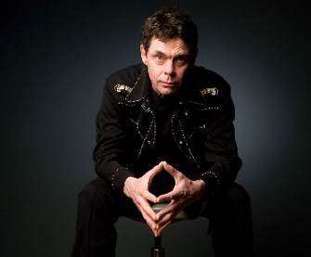

Stand Up in The Park: Russell Kane, Rich Hall and Angela Barnes
Friday 23 July
7.30pm (Gates 6.30pm)
Campbell Park: Amphitheatre (nearest postcode MK9 3FT)
Tickets: £27.50. Ages 16+
The multi-award-winning TV regular, presenter, actor, author and scriptwriter Russell Kane, expertly crafted tirades and quick-fire banter from Rich Hall, and gloriously down-to-earth, straight talking wit from Angela Barnes.

Russell Kane: https://www.russellkane.co.uk/
Rich Hall: https://offthekerb.com/artist/rich-hall/
Angela Barnes: https://www.angelabarnescomedy.co.uk/

Website: https://ifmiltonkeynes.org/event/stand-up-in-the-park-comedy

For Campbell Park Amphitheatre:
Drop off and Pick up point is at Campbell Park, opposite the Budgens shop on Avebury Boulevard.

Wheelchair access to the Amphitheatre is by Campbell Heights Housing Development.

From the Plateau, there are paths to lead you to the Amphitheatre.

Assistance Dogs Welcome
BSL Interpreted
Disabled Parking available for Blue Badge Holders
Drop-Off and Pick-Up Point available
Assistive Listening and Hearing Loop available
Seating available
Wheelchair Accessible
Make Some Noise
Outdoor Event
Additional information
There is a Pedestrian trackway leading to a designated viewing area
There is an Accessible route into the Amphitheatre – Please ask a steward to guide you
Accessible event toilets available on events plateau

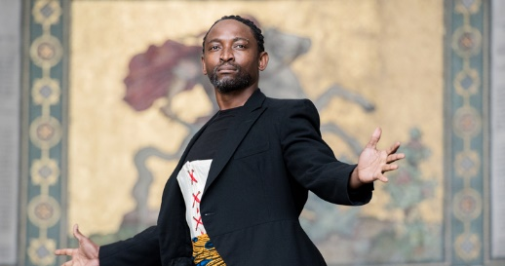

Black Victorians created by Jeanefer Jean-Charles
Saturday 24 and Sunday 25 July
Peace Pagoda, North Willen Lake
Saturday 24 July: 3pm and 7pm
Sunday 25 July: 12noon and 3pm
FREE: Book a ticket
A dance performance taking in African, hip-hop and contemporary styles, inspired by hundreds of studio photographs of black people from the Victorian era, airbrushed from our society for over 100 years.

Artist: http://www.jeanefer.com/
Website: https://ifmiltonkeynes.org/event/black-victorians

Audio Described show by VocalEyes
Saturday 24 July, 3pm performance of Black Victorians
Please email access@stables.org to book a place
Pre-Show Tour for Blind and Visually Impaired People
Led by VocalEyes Audio Describer, Sophia Knox-Miller
Saturday 24 July: Arrive at 2.15pm to register
Free: Book a place
The tour will provide background for the Black Victorians performance at 3pm, to enhance the experience of this performance, which is Audio Described.
The Tour will explore the Peace Pagoda setting for the performance, before meeting a member of the production’s company.

To book please email Ursula White: Ursula.white@stables.org
Website: https://ifmiltonkeynes.org/event/black-victorians-pre-show-tour-for-blind-visually-impaired-people

Assistance Dogs Welcome
Disabled Parking
Drop-Off and Pick-Up Point
Assistive Listening and Hearing Loop available
Disabled Toilets available
Wheelchair Accessible – please see notes below

What to Expect
Family Friendly
Outdoor Event
Additional information
Drop-Off and Pick-Up Point available for wheelchair users https://goo.gl/maps/s73qnPLANkmdVDNo7

Along the road leading to the identified accessible carpark (shown here: https://goo.gl/maps/s73qnPLANkmdVDNo7) there are a number of speed humps and potholes - please drive carefully.

Paved route from access parking to the Peace Pagoda is approximately 10 mins walk/wheel
Close to The Pagoda there is a long slope approximately 1:14 gradient leading to the Pagoda - wheelchair users may require an assistant.
The area surrounding the Pagoda intended for audiences is firm ground. Trackway may be applied to grass surface dependent on weather.
Please email: access@stables.org if you have any concerns about accessing this site

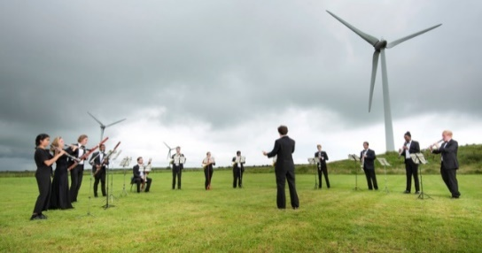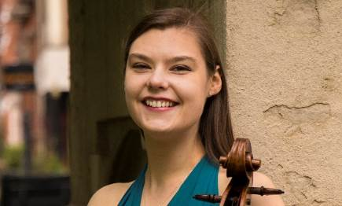

Orchestra for the Earth: For the Trees
Saturday 24 July, 8pm (Gates 6.30pm)
Campbell Park: Amphitheatre (Nearest postcode MK9 3FT)
Tickets: £22.50, Under 24 years £11
Soloist: Rebecca McNaught (cello)
Conductor: John Warner

Repertoire:
Frank Bridge: Moonlight (from the Sea Suite for Orchestra)
Elgar: Cello Concerto in E Minor Op 85
Beethoven: 2nd Symphony in D Major Op

Nature and music come together for this glorious concert to harness the power of music, inspiring audiences to love, understand and protect our planet, and also support the conservation charity Trees of Music.

Orchestra: https://www.orchestrafortheearth.co.uk/
Webpage: https://ifmiltonkeynes.org/event/orchestra-for-the-earth

For Campbell Park Amphitheatre:
Drop off and Pick up point is at Campbell Park, opposite the Budgens shop on Avebury Boulevard.

Wheelchair access to the Amphitheatre is by Campbell Heights Housing Development.

From the Plateau, there are paths to lead you to the Amphitheatre.

Assistance Dogs Welcome
Assistive Listening and Hearing Loop available
Seating Available
Wheelchair Accessible

What to Expect
Outdoor Event
Additional information
The walking-access route into the area is via a steep slope.
Pedestrian trackway leading to viewing area
Designated viewing area
Accessible route into site provided.
Accessible event toilets on events plateau

For questions of if you have any concerns about access to the Amphitheatre please contact: access@stables.org

IF: ONLINE
The Festival’s programme of events presented online includes podcasts, talks, films, concerts and more. All events are free, with many live-streamed or on-demand.
Find out more here: https://ifmiltonkeynes.org/if-online

IF: Milton Keynes International Festival 2021
10-30 July

www.ifmiltonkeynes.org
https://ifmiltonkeynes.org/

Festival Social media:
Twitter and Facebook: @IFMKfest
Instagram: ifmkfest
Hashtag: #IFMKfest

Document Ends

